EXPERIMENT-11
Random Sampling and Sampling Distribution
Aim:
To explore random sampling from population and understand the concept of sampling distribution
Procedure:
- Create a population of data with specified distribution
- Perform random sampling from population to create multiple sample of different sizes
- Compute sample statistics
- Plot histograms or density plots of each statistics
- Compare the sampling distribution of the sample statistic of the sample statistic with mean distribution

Program: 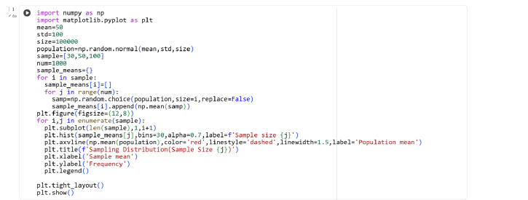

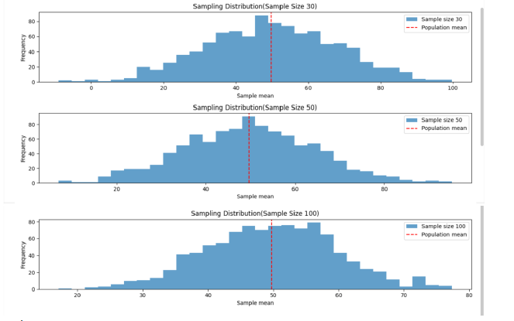
Result:
Thus the python program for random sampling and sampling distribution is executed and output is verified successfully

